Chris Thomas
1/29/2021
EET 127

- Compare and contrast the similarities and differences between a PC Desktop and the Linux Desktop running on the Pi.
a) While many things feel familiar there are plenty of subtle differences between Windows and the Linux based system. The first and most noticeable difference is how much you will use the Terminal to run and install new applications. Before I took programming classes I never used the Console in Windows. Also the amount of customization available with a Linux based system is far greater than your standard Windows Desktop.
- List the names and purposes of the icons that are in the application menu
a) Programming – Contains all the programming languages installed on the Pi.
b) Office – Just like Microsoft Office has all of your spreadsheet and Word applications.
c) Internet – Contains all of your web browsers.
d) Games – Contains all of the games installed.
e) Accessories – Contains helpful applications such as Calculator and Terminal
f) Help – Contains all available help and FAQ for the Pi.
g) Run – Just like in Windows where you go to execute certain programs.
h) Shutdown – Contains shutdown, restart, and logoff.
- What did you thing of the package SCROT?
a) It was nice and took a good screenshot not sure how much I would appreciate needing to use console commands to take a screenshot.
- What packages did you install using Synaptic?
- I installed gimp, arduino, and fritzing since I could see myself using each one of these in the near future.
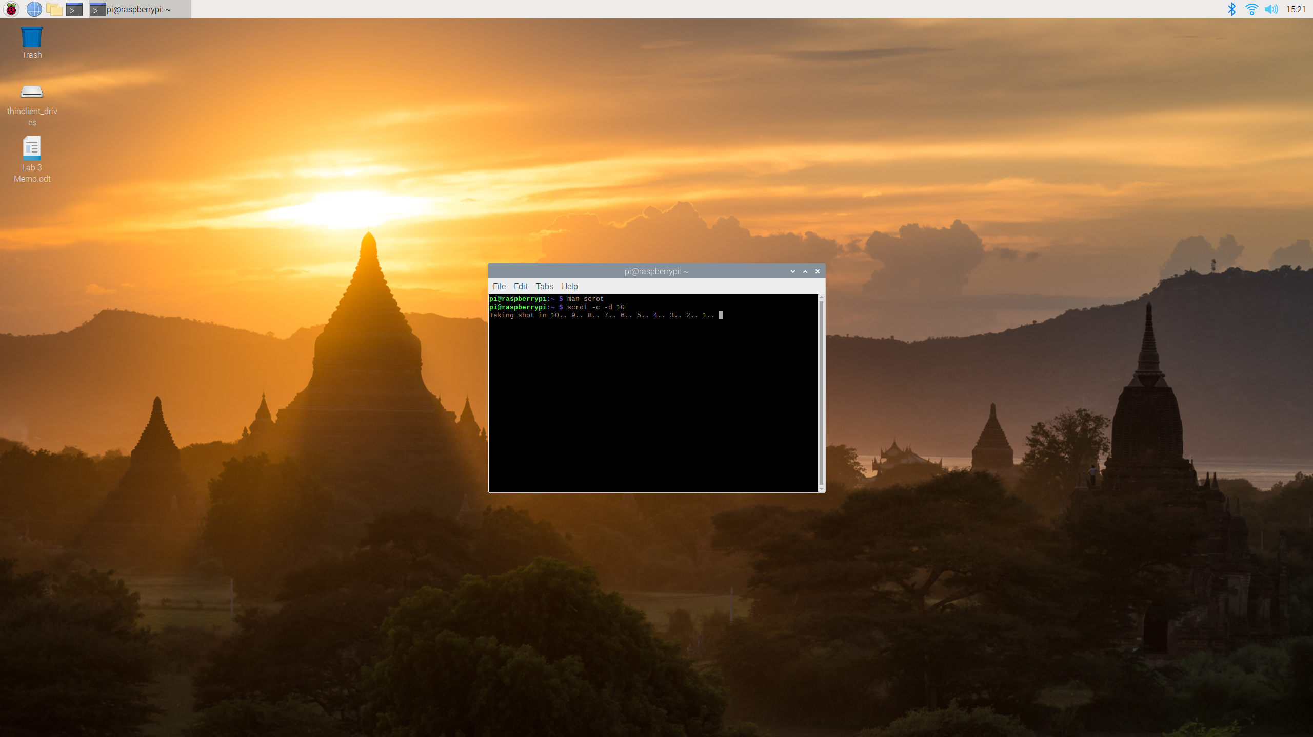
Memo: Experience with Raspbian Desktop
So far I think I actually prefer this to the Windows 10 system I use on my Desktop at home. Very clean and customizable also clear on where you can find what you are looking for.

